Create a Pumping Rosette in Fusion

- Create a sketch on the top origin plane.
- Start by drawing a circle with the final desired diameter.
- Draw two radii with an included angle matching the desired number of lobes.
- Trim the circle to the radii.
- Draw a circle with a diameter 2mm less than the final desired diameter.
- Draw another circle representing the center opening.
- Draw yet another representing the boss (This is optional).
- 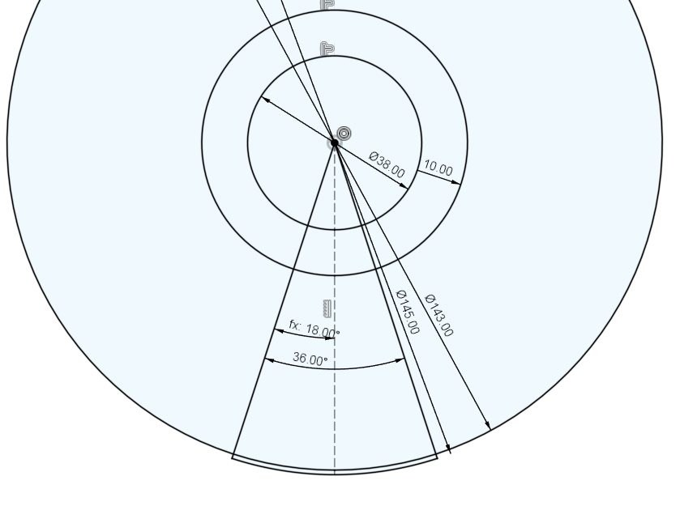
- Extrude the profile created by the circles in steps 5 and 6 (or 7) with a height equal to the desired amplitude.
- Create a plane perpendicular to the first plane and outside of the circle created in step 2.
- Create a rectangle with a length equal to the length of the arc created in step 4 and a height equal to the amplitude.
- Draw the desired pumping profile between opposite corners of the rectangle.
- 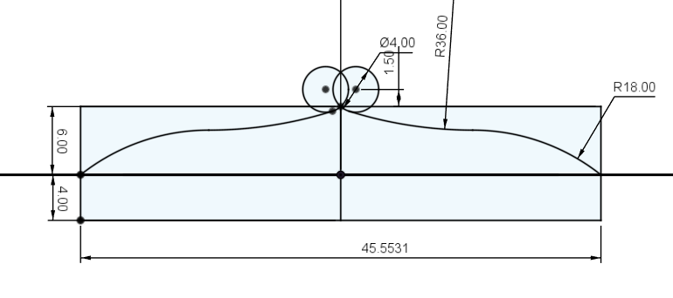
- Emboss with a depth of 1mm the profile to the cylinder created in step 9.
- 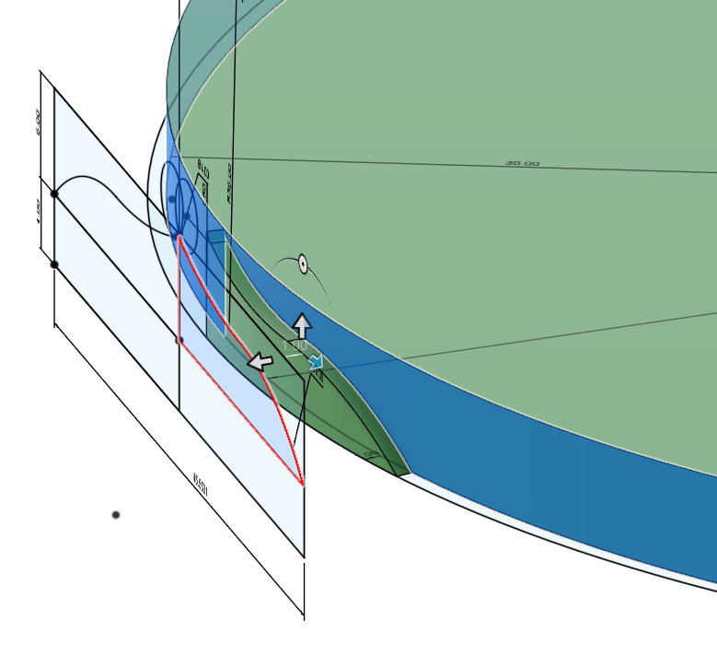
- Use the Split Body command to separate the embossed body from the cylinder.
- Hide the cylinder.
- Press/Pull the inner face of the embossed body to either the boss or the center hole.
- 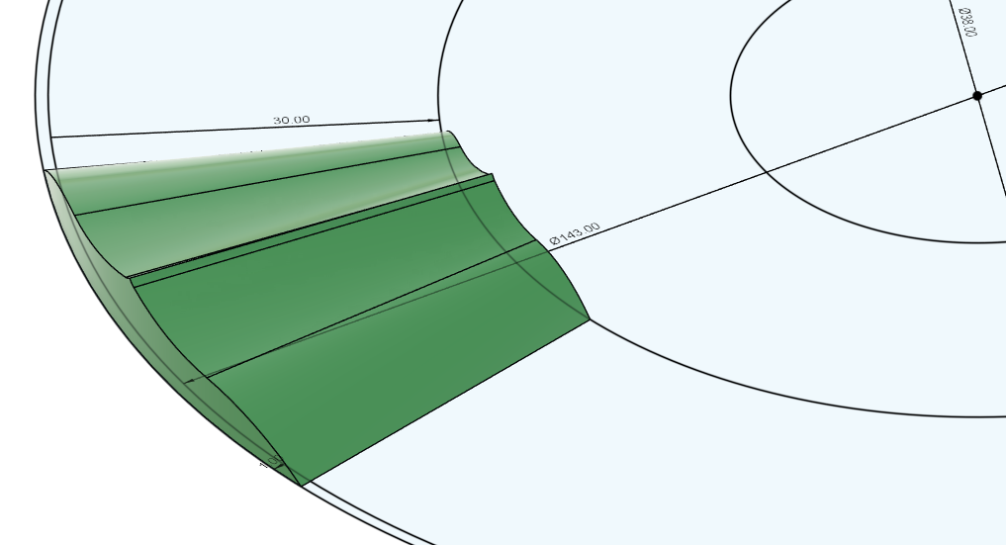
- Circular Pattern this body.
- Combine the bodies.
- 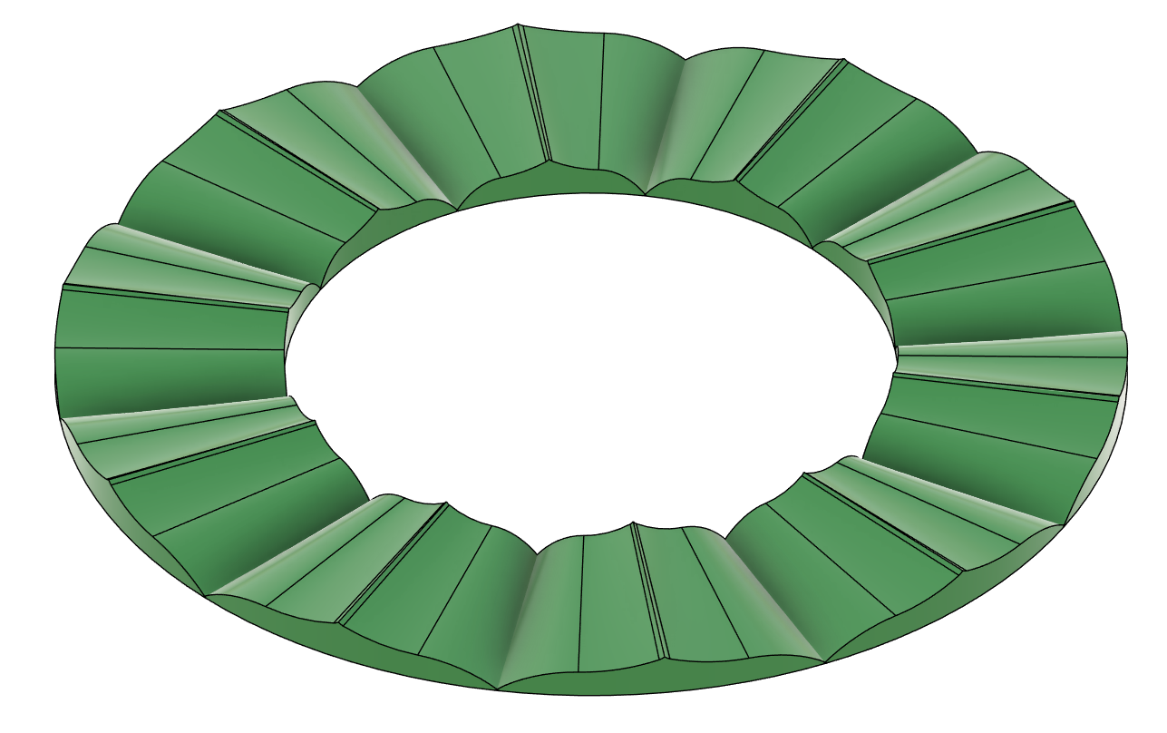
- Extrude the bottom of the combined body to the desired height of the rosette.
- If you press/pulled to the boss, then extrude the boss to match the height in the previous step.
- 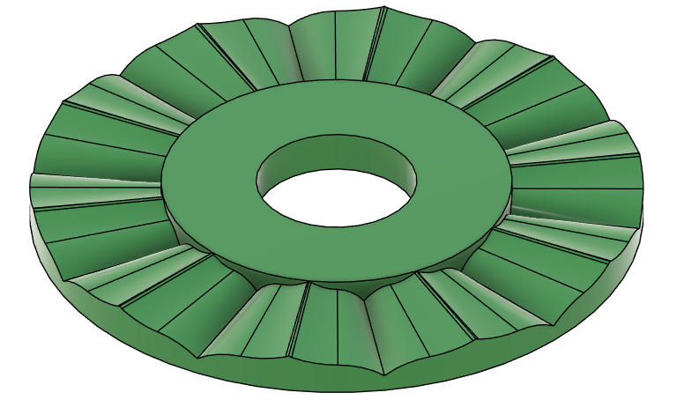

You can also loft to a point to create a variable amplitude rosette:
